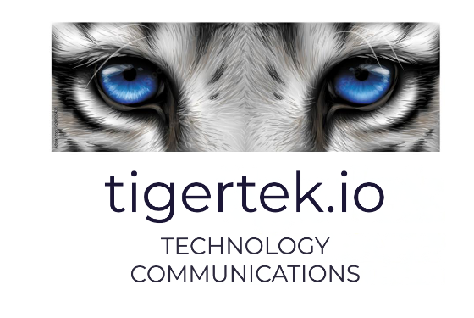

Diversity and Inclusion Policy for Tigertech Communications Ltd.
1. Policy Statement
Tigertech Communications Ltd. is committed to fostering a diverse, inclusive, and equitable workplace where all employees are respected, valued, and empowered to contribute fully. We believe that diversity strengthens innovation, enhances collaboration, and drives business success.
We are dedicated to maintaining a working environment free from discrimination, harassment, victimization, and bias, and to promoting equality of opportunity across all aspects of employment.

2. Purpose
The purpose of this policy is to:
- Promote diversity and inclusion across the organization
- Ensure fair and equitable treatment for all employees and applicants
- Prevent discrimination, harassment, and unfair practices
- Establish clear responsibilities for maintaining an inclusive culture
- Support compliance with applicable employment and anti-discrimination laws

3. Scope
This policy applies to:
- All employees (permanent, temporary, contract, and part-time)
- Directors and officers
- Consultants, contractors, and agency workers
- Job applicants
- Interns and volunteers
It covers all employment-related activities including recruitment, hiring, compensation, promotion, training, performance management, and termination.

4. Our Commitment
Tigertech Communications Ltd. is committed to:
4.1 Equal Opportunity
Providing equal employment opportunities regardless of:
- Race, ethnicity, or nationality
- Gender, gender identity, or gender expression
- Sexual orientation
- Age
- Disability
- Religion or belief
- Marital or family status
- Socioeconomic background
- Any other characteristic protected by law
Employment decisions will be based solely on merit, qualifications, performance, and business needs.
4.2 Inclusive Workplace Culture
We strive to create a culture where:
- Differences are respected and celebrated
- Employees feel safe to express ideas and perspectives
- Collaboration across diverse backgrounds is encouraged
- Bias—conscious or unconscious—is actively addressed
4.3 Zero Tolerance for Discrimination and Harassment
Tigertech Communications Ltd. will not tolerate:
- Direct or indirect discrimination
- Harassment or bullying
- Victimization or retaliation
- Offensive, degrading, or exclusionary behavior
All complaints will be taken seriously and handled confidentially and fairly.

5. Responsibilities
5.1 Leadership and Management
Leaders and managers are responsible for:
- Demonstrating inclusive leadership behaviors
- Ensuring fair and objective decision-making
- Addressing inappropriate behavior promptly
- Encouraging open dialogue and participation
- Supporting diversity initiatives and training
5.2 Employees
All employees are expected to:
- Treat colleagues, clients, and stakeholders with dignity and respect
- Challenge discriminatory or exclusionary behavior
- Participate in diversity and inclusion initiatives
- Report concerns or violations of this policy
5.3 Human Resources
HR is responsible for:
- Implementing fair recruitment and promotion practices
- Providing training on diversity, inclusion, and unconscious bias
- Monitoring workforce diversity data (where appropriate and lawful)
- Investigating complaints in line with company procedures

6. Recruitment and Advancement
Tigertech Communications Ltd. is committed to:
- Advertising vacancies in ways that reach diverse candidate pools
- Using objective, competency-based selection criteria
- Providing reasonable accommodations for candidates and employees with disabilities
- Ensuring promotion and development opportunities are accessible to all

7. Training and Awareness
The company will:
- Provide diversity and inclusion training
- Offer guidance on unconscious bias and inclusive communication
- Encourage ongoing learning and dialogue around equity and belonging

8. Reporting Concerns
Employees who believe they have experienced or witnessed discrimination, harassment, or unfair treatment should report concerns to:
- Their line manager
- Human Resources
- A designated senior leader
All reports will be handled confidentially to the extent possible and without retaliation. Retaliation against individuals who raise concerns in good faith will not be tolerated.

9. Monitoring and Review
Tigertech Communications Ltd. will:
- Periodically review diversity and inclusion metrics
- Assess recruitment, promotion, and retention data
- Review this policy annually to ensure continued effectiveness
- Make improvements where gaps or inequities are identified

10. Policy Governance
This policy is approved by senior leadership and forms part of Tigertech Communications Ltd.’s commitment to ethical business conduct and corporate responsibility.
Failure to comply with this policy may result in disciplinary action, up to and including termination of employment.

Approved by: P. Campbell
Position: Director
Effective Date: 18th. February 2026

