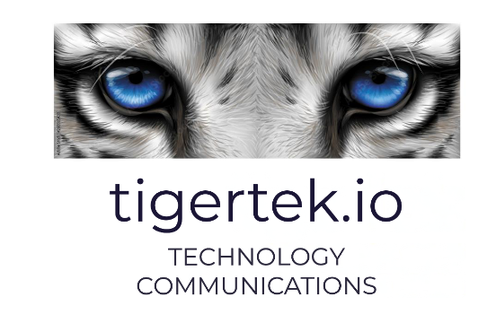
Modern Slavery and Human Trafficking Statement for Tigertech Communications Ltd.
(aligns with Section 54 of the UK Modern Slavery Act 2015)
Modern Slavery and Human Trafficking Statement
Tigertech Communications Ltd
1. Introduction
This statement is made pursuant to Section 54 of the Modern Slavery Act 2015 and sets out the steps taken by Tigertech Communications Ltd (“Tigertech”, “we”, “our”, or “the Company”) to prevent modern slavery and human trafficking in our business operations and supply chains during the financial year ending [Insert Date].
Tigertech Communications Ltd has a zero-tolerance approach to modern slavery and is committed to acting ethically, with integrity and transparency in all business dealings.

2. Our Business
Tigertech Communications Ltd is a [insert brief description – e.g., telecommunications services provider / communications technology company] operating in [insert operating regions, e.g., the United Kingdom and internationally].
Our core activities include:
IoT communications technology services
We operate primarily from Northern Ireland and our supply chains include providers of:
- Telecommunications infrastructure and hardware
- IT systems and software
- Professional and consultancy services
- Facilities management and office services

3. Our Commitment
Tigertech is committed to:
- Prohibiting all forms of modern slavery, servitude, forced or compulsory labour, and human trafficking
- Ensuring that all employees are treated with dignity and respect
- Maintaining fair recruitment and employment practices
- Working only with suppliers and partners who share our commitment to ethical business practices
We expect the same high standards from all of our contractors, suppliers, and business partners.

4. Policies and Governance
To support our commitment, Tigertech has implemented the following policies:
- Code of Conduct – setting out ethical standards and expected behaviours
- Anti-Bribery and Corruption Policy
- Whistleblowing Policy – enabling employees and third parties to report concerns confidentially
- Recruitment Policy – ensuring fair and lawful employment practices
- Supplier Code of Conduct (where applicable)
These policies reflect our commitment to acting responsibly and with integrity across all areas of our operations.

5. Risk Assessment and Due Diligence
We assess the risk of modern slavery in both our business and supply chain by:
- Reviewing the geographic locations in which suppliers operate
- Assessing the nature of goods and services supplied
- Conducting supplier onboarding checks
- Requesting supplier confirmations of compliance with applicable labour laws
Where higher-risk suppliers are identified, we may:
- Request additional information regarding labour practices
- Include specific contractual clauses requiring compliance with anti-slavery legislation
- Reassess or terminate supplier relationships where standards are not met
Given the nature of our business operations, we consider the risk of modern slavery within our directly employed workforce to be low. However, we recognise that risks may exist within global supply chains and remain vigilant.

6. Training and Awareness
Tigertech promotes awareness of modern slavery risks by:
- Providing relevant training to employees, particularly those involved in procurement and supplier management
- Communicating our zero-tolerance stance internally
- Encouraging staff to report concerns via our whistleblowing channels

7. Reporting Concerns
Employees, contractors, and third parties are encouraged to report any concerns relating to modern slavery or unethical practices. Reports can be made confidentially through our whistleblowing procedures.
Tigertech will investigate all credible concerns and take appropriate action.

8. Ongoing Commitment
We are committed to continuous improvement in preventing modern slavery and human trafficking. In the coming year, we aim to:
- Further strengthen supplier due diligence processes
- Review and update supplier contractual clauses where necessary
- Enhance internal awareness training

9. Approval
This statement has been approved by the Board of Directors of Tigertech Communications Ltd and is signed on its behalf.

Name: P. Campbell
Title: Director
Date: February 2026

